23/9/26
GENETIC ALGORITHM FOR OPTIMISATION PROBLEMS import random
items = [(10, 5), (40, 4), (30, 6), (50, 3), (35, 2)] capacity = 10 population_size = 8 generations = 10 def fitness(gene):
total_value, total_weight = 0, 0 for bit, (value, weight) in zip(gene, items):
if bit == 1:
total_value += value total_weight += weight
return total_value if total_weight <= capacity else 0
def random_gene():
return [random.randint(0,1) for _ in items]
def crossover(parent1, parent2):
point = random.randint(1, len(items)-1) return parent1[:point] + parent2[point:]
def mutate(gene): i = random.randint(0, len(gene)-1) gene[i] = 1 - gene[i] return gene
population = [random_gene() for _ in range(population_size)] for gen in range(generations):
population = sorted(population, key=fitness, reverse=True) best = population[0]
print(f"Gen {gen+1}: Best gene {best}, Value = {fitness(best)}") new_pop = [best[:]] while len(new_pop) < population_size:
p1, p2 = random.sample(population[:4], 2) # select parents child = crossover(p1, p2) if random.random() < 0.3: # mutation chance
child = mutate(child)
new_pop.append(child)
population = new_pop
print("\nOptimal Solution Found:") print("Gene:", best) print("Value:", fitness(best))
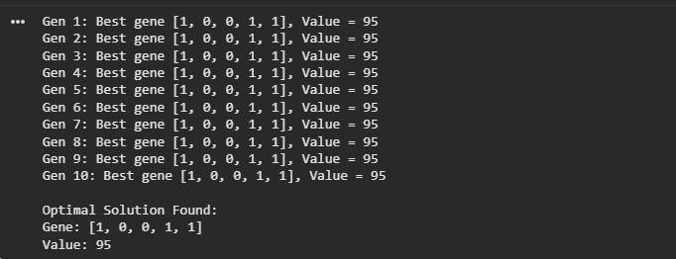
O
U
T
P
U
T
:
30/09/2026
PARTICLE SWARMOPTIMISATION import random, math
cities = [(0,0), (2,3), (5,2), (6,6), (8,3)] def dist(a, b):
return math.sqrt((a[0]-b[0])**2 + (a[1]-b[1])**2)
def route_length(route):
return sum(dist(cities[route[i]], cities[route[(i+1)%len(route)]]) for i in range(len(route)))
num_particles = 6 iterations = 10
particles = [random.sample(range(len(cities)), len(cities)) for _ in range(num_particles)] pbest = particles[:]
pbest_val = [route_length(p) for p in particles] gbest = pbest[pbest_val.index(min(pbest_val))] gbest_val = min(pbest_val) for t in range(iterations):
for i in range(num_particles):
a, b = random.sample(range(len(cities)), 2)
particles[i][a], particles[i][b] = particles[i][b], particles[i][a] val = route_length(particles[i]) if val < pbest_val[i]:
pbest[i], pbest_val[i] = particles[i][:], val
best_val = min(pbest_val) if best_val < gbest_val: gbest_val = best_val
gbest = pbest[pbest_val.index(best_val)]
print(f"Iter {t+1}: Best route length = {gbest_val:.2f}")
print("\nOptimal Route Found:") print("Route:", gbest) print("Distance:", gbest_val) OUTPUT:
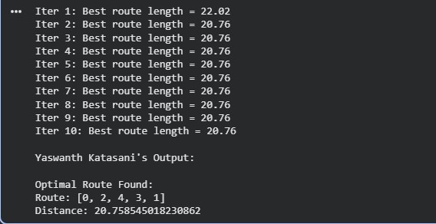
07/10/2026
OPTIMISATION VIA GENEEXPRESSION import random
items = [(10, 5), (40, 4), (30, 6), (50, 3), (35, 2)] capacity = 10 population_size = 6 generations = 5 def fitness(gene):
total_value, total_weight = 0, 0 for bit, (value, weight) in zip(gene, items):
if bit == 1:
total_value += value total_weight += weight
return total_value if total_weight <= capacity else 0
def random_gene(): return [random.randint(0,1) for _ in items]
def mutate(gene): i = random.randint(0, len(gene)-1) gene[i] = 1 - gene[i] return gene
population = [random_gene() for _ in range(population_size)] for gen in range(generations):
population = sorted(population, key=fitness, reverse=True) best = population[0]
print(f"Gen {gen+1}: Best gene {best}, Value = {fitness(best)}") new_pop = [best[:]] while len(new_pop) < population_size:
child = mutate(best[:]) new_pop.append(child) population = new_pop print("\nOptimal Solution Found:") print("Gene:", best) OUTPUT:
